**Linking Canvas to PowerSchool (required):**

All official grades should be entered into PowerSchool. Students should look there for their official grades and that is how their report cards will be generated. Starting Fall 2022, teachers should also link their Canvas assignments to PowerSchool. Some reason/benefits:

* If students will be submitting work on Canvas, then this implies that you will already be creating the assignment once.
* Creating the assignment on Canvas will automatically create a calendar event for students and their parents to see.
* In general, entering grades on Canvas is much more convenient than entering them on PS (my opinion).
* Ever since 2017, there is no smartphone app for teachers to enter grades directly into PowerSchool. However, teachers can enter grades on the Canvas app and PowerSchool will be automatically updated.

**Step 1: Disable Totals (whether or not you wish to sync gradebooks)**

In our first year with Canvas (2020-2021) there were some issues with Canvas showing the student one cumulative grade and PowerSchool showing another. Since PowerSchool is king, it is a good idea to disable Canvas from showing students a final grade. Then when you enter individual scores on Canvas, they will be visible to students and Canvas will ferry the scores into PowerSchool, but only PowerSchool will be able to tell students what their current semester grade is. So before doing any of the syncing steps below, ***do the following for EACH of your classes:***

1. 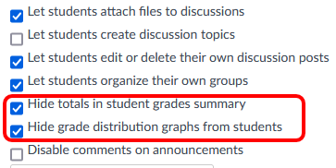On the left side, click on “Settings”
2. At the top, select the “Course Details”
3. Scroll down and click on “more options”
4. Make sure “Hide totals…” is selected
5. (While you are there, please also make sure “Hide grade distribution…” is selected. Otherwise, Canvas will tell students *what* the highest and lowest scores were on any assignment. In a small class, students can easily figure out *whose* grades those were. In the future, that box may be automatically checked district-wide.)

**Step 2: Connect the Gradebooks**

Most of the steps to link Canvas and PowerSchool will take place in Canvas under the “Assignments” and “Grades” tabs. They must be done for each class that you want to link. Here are the general steps:

1. 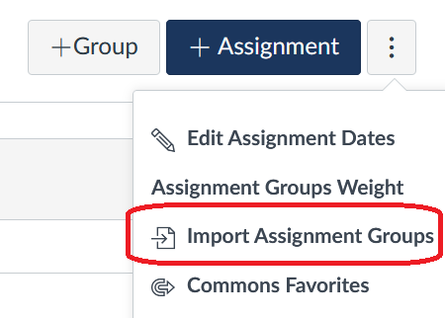Set up all your assignment groups in PowerSchool. ***Indeed, you should set up your entire PowerSchool gradebook and grading schemes first, since the PowerSchool grade is the one that really matters.***
2. In Canvas 🡪 Assignments, click on the $⋮$ 3 dots  
   Select “Import Assignment Groups”

You should receive a message that the request was received.  
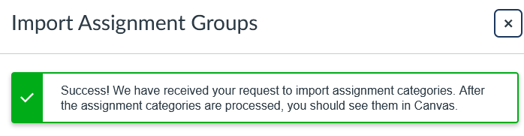  
\*\**For one of my classes, it took less than 15 minutes for the categories to be imported. For another, it took much longer. You can check whether your categories are imported by refreshing the Assignments page.* **   
  
After your categories have been imported you will see new Assignment Groups at the bottom of your Assignments page. You can tell that these are special Groups, because they will have the following icon:  
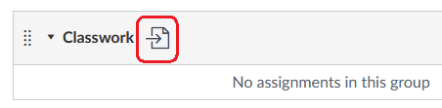  
  
Hovering your mouse over this icon will show “Imported from PowerSchool.”  
If you had previously tried unsuccessfully to create assignment groups (like me!), then you might have their old carcasses sitting around. If an unwanted assignment group is empty, you may delete it. If it is not empty, drag its content to the new appropriate assignment group(s). Then you can delete the unwanted assignment group.  
  
iSC has 4 PowerSchool categories that exist by default. They are marked with the following logo in Power Teacher Pro (under “Grading” 🡪 “Categories”).  
  
ALL your PowerSchool categories will show up when you import to Canvas, including categories that you do not intend to use. Once they import, you may freely delete from Canvas any that you will not be using. (I never use “Project” or “Other,” so I deleted them in Canvas after importing.)

**Step 3: Try it!**

Time to create an assignment and input a grade! Pick a category and create an assignment.  
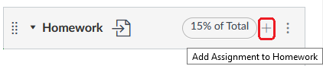  
  
The assignment must be published (solid green circle with a white check mark) before it can be synced it to PowerSchool.

$↙$ An unpublished assignment will have this icon.

Click the circle to publish it. Then refresh the page.

Here is an assignment that has been published, but has not been categorized as one that I want to sync to PowerSchool:   
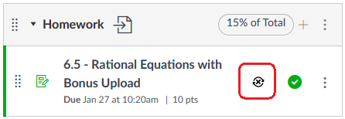  
  
To categorize it as one that should be synced, click the black button shown above. It will turn to another green check mark.  
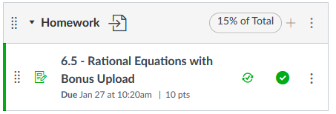  
  
To assign a grade you may either:  
 - Click on the assignment 🡪 Speed Grader  
 - On the left pane, click on “Grades” (my preference)

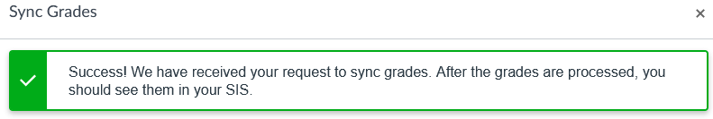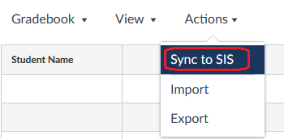**Step 4: Controlling Syncing**  
If you immediately go check PowerSchool, you will not see the assignment you just created in your Assignment List. This is because Canvas does not continually sync but rather syncs when told to. Here is one way to tell it to sync:  
  
On the navigation pane on the left, click on “Grades”  
Select “Actions” 🡪 Sync to SIS.

\*\**Syncing this way usually takes 2-15 minutes.*\*\*

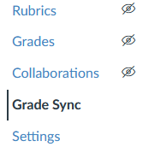  
If you would like to have your Canvas assignments sync with PowerSchool every night (right after midnight China time, by my experience), click on “Grade Sync,” select “Settings,” and enable “Nightly Sync.” You can still sync manually, as shown above, but Nightly Sync will be a backup, in case you ever forget.  
  
Weird: If you cannot see “Grade Sync” on the left, go to Settings 🡪 Navigation and make sure “Grade Sync” is dragged to the UPPER section. Normally this means that students can see it. But in this case it just means that you can see it. Yep. Weird.

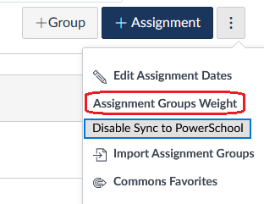**Step 5: Weights (optional)**  
  
If your PowerSchool gradebook is set up using weights, you can set the same weights in Canvas, so that the score on Canvas *should* match the students’ semester scores in PowerSchool (prior to the final exam). Of course, the student will not see their semester score in Canvas (see Step 1 above), but **you** might like to see it to confirm there are no glitches between PS and Canvas.

At the top right of the assignments page, click the $⋮$ 3 dots and select “Assignment Group Weight.”  
Go through and add the correct percentages to each category.

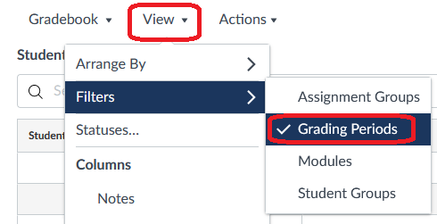**Step 6: Starting 2nd Semester (only applies to year-long courses)**  
When second semester starts, you will ***Not*** need to repeat any major setup steps. But you will want to change your view.

In your gradebook, select  
View 🡪 Filters 🡪 Grading Periods

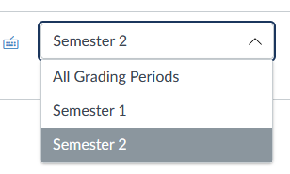Then on the right, select Semester 2.

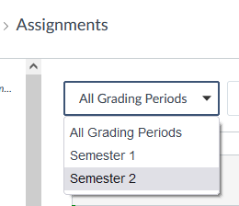

Then go to your Assignment page. At the top left change the grading period to Semester 2.

When you do this, everything from 1st semester will be hidden, including the assignment categories. To get a category to reappear, simply create a new assignment using that category.

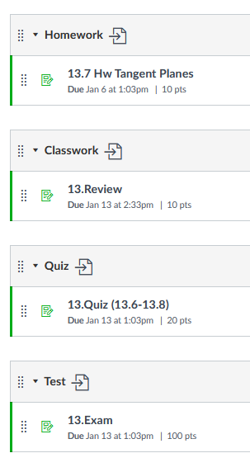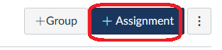

If you have any trouble, you might need to refresh your page and try again.

I personally like to go ahead and create one assignment for each of my categories, just to get all the categories to show.

**Checklist for Each Canvas Class**

Left-side navigation has 5 buttons or fewer visible to students (some exceptions)

Other left buttons are organized for teacher’s sanity ☺

Forethought on notification settings.

Green nightly sync button turned on.

First few assignment made with correct structure "1.a - Hamlet Pre-reading"

Run link checker to find bad links. (esp if copying an old course)

If a parent lands on your home page, there are probably 3 things they might want:

- contact teacher (list your email or put instructions for Canvas Inbox)

- See upcoming assignments (help them find it)

- See grades

Make something that (1) is easy for them to see and (2) which does all these things.

**Glitches with Syncing**

(In order of what you should check first

**“I entered the grade in Canvas, but it did not change in PowerSchool.”**

Go to “Grade Sync” (see step 5 above).   
It will show you the status of recent sync attempts.

What does it show?

It shows a sync, but it failed

It says there was a successful sync

It doesn’t show any sync for the relevant time period.

It might have glitched on a previous sync. Then, when it tried again, it thought there were no new grades. (It only syncs grades that it thinks are new.)

* Simple fix:
  + Try changing the relevant grade (maybe 10 🡪 9.5)
  + Manually sync
  + Wait until the new grade shows in PS.
  + Change the grade back in Canvas. Sync again.
* Check the assignment title and the heading in the assignment details. Their name should have 30 or fewer characters (including spaces)
* Make sure you do not have two assignments with the same name.
* Make sure that the date of the assignment is within the date range (such as S1) that you are viewing in PS.
* ***The Ultimate Heavy-Duty Fix:***  
  Grade Sync 🡪 Utilities 🡪 “Remaster Grade Passback”  
  This will resync your entire gradebook. It might take a while. Be sure not to start another sync while this one is running.

Try these

* Click on the fail link and read the message
* Check the assignment title and the heading in the assignment details. Their name should have 30 or fewer characters (including spaces)

Go back to the Canvas gradebook and try to manually sync again. Go back to “Grade Sync” and wait while it tries to sync

Does it still not show a sync? You might have an error with how you linked to PowerSchool.

A couple helpful links regarding syncing issues:

<https://www.youtube.com/watch?v=9QoaVM8t36E>

<https://community.canvaslms.com/t5/PowerSchool-and-Canvas/How-do-I-remaster-grade-passback-and-re-sync-my-entire-Canvas/ta-p/493066>

Have a correction? Please let me know! steven.malan@isqchina.com